
SCHOOL OF COMPUTING AND ENGINEERING SCIENCES (SCES)
BACHELOR OF SCIENCE IN ELECTRICAL AND ELECTRONICS
ENGINEERING (BSEEE)
DIGITAL CONTROL 1
LAB 1:
CONTROL SYSTEMS 1 REPORT ON SYSTEM RESPONSE
BY
Edward Mwongela – 142092

Group members
Esther Wangari Mugambi - 145822
Ian Katuku - 143367

Lecturer: Dr. Victor Rop
Supervisor Simon Juma

Due: 21st May 2025

Abstract
This lab report investigates the step response characteristics of control systems in open-loop, negative feedback, and positive feedback configurations. MATLAB simulations were used to analyse transient and steady-state behaviours, including rise time, settling time, overshoot, and steady-state error. The study highlights the trade-offs between stability, speed, and accuracy in different feedback configurations and demonstrates the effectiveness of a PI controller in eliminating steady-state error for a first-order system with time delay.

Table of Contents
Abstract 2
List of figures 3
Objective and Theory of Operation 5
1.1 Objective 5
1.2 Theory of Operation 5
System Representations 5
Key Metrics 7
Calculations 9
2.1 Pre-Lab Calculations 9
Results and Discussion 10
3.1 Step Response Metrics (H(s)=1 10
3.2 Effect of Increased Feedback Gain (H(s)=3 10
3.3 PI Controller for Chemical Reactor 11
Exercise: PI Controller Design for Chemical Reactor 12
4.1 Solution 12
4.2 Results and Discussion 13
Conclusions and Recommendations 14
5.1 Conclusions 14
5.2 Recommendations 14
5.3 Challenges 14
References 14
Appendices 15

List of figures
Figure 1. Negative Feedback Closed Loop curve when H=1 15
Figure 3. Open Loop Curve when H=1 15
Figure 2. Comparison graph when H=1 15
Figure 4. Positive Feedback Closed Loop Curve when H=1 15
Figure 5. Data Obtained from negative feedback when H=1 16
Figure 7. Data obtained from Open Loop when H=1 16
Figure 6. code 1 16
Figure 8. Data obtained from Positive Feedback when H=1 16
Figure 10. Open Loop curve when H =3 16
Figure 9. Negative Feedback curve when H=3 16
Figure 11. Comparison graph when H=3 17
Figure 12. Positive Feedback curve when H=3 17
Figure 13. Negative Feedback data when H=3 17
Figure 14. Open loop data when H=3 17
Figure 15. Positive feedback data when H=3 17
Figure 16. code 2 18
Figure 17. code 3 18
Figure 18. code 4 18
Figure 19. code 5 18
Figure 20. MATLAB Code for Exercise 19
Figure 21. MATLAB Code for the PI Controller exercise 19
Figure 22. PI Controller curve for exercise 19
Figure 23. Open Loop curve with time delay for exercise 19

Objective and Theory of Operation

1.1 Objective
The primary objective of this lab is to analyze the step response characteristics of a control system in three configurations:
- Open loop: To observe the system’s inherent dynamics without feedback.
- Negative feedback: To study how feedback improves stability and reduces steady-state error.
- Positive feedback: To demonstrate the risks of instability and unbounded growth.
Additionally, the lab aims to:
- Derive and simulate transfer functions for each configuration using MATLAB.
- Compare performance metrics (rise time, settling time, overshoot, steady-state error).
- Design a PI controller for a first-order system with time delay and evaluate its effectiveness.
Simulation Tools
- MATLAB for transfer function implementation and step response analysis.
- Metrics extracted: Rise time, settling time, overshoot, and steady-state error.

1.2 Theory of Operation

System Representations
- Open-Loop System:
Definition: Operates without feedback; output depends solely on input and plant dynamics.
An open-loop control system acts entirely on the basis of input without using feedback. It does not compare the output with the desired reference, hence it cannot correct any errors. Though simple and cost-effective, open-loop systems are generally less accurate and more susceptible to disturbances and component variations. Therefore, a pure open-loop system lacks self-correction and typically exhibits larger errors.
Transfer Function:
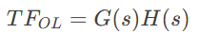
Characteristics:
    - Simple but prone to disturbances.
    - No self-correction (steady-state error depends on system gain).
- Closed-loop systems
Use feedback to compare the output to the input and reduce the error. Feedback is the process of returning a portion of the output to the input to modify system behavior. This improves the stability, accuracy, and disturbance rejection.
- Negative Feedback System:
Definition: Output is compared to input to reduce error.
In negative feedback systems, the output is subtracted from the reference input. Negative feedback improves stability, reduces sensitivity to component variations, and decreases steady-state error (which increases accuracy).
Transfer Function:
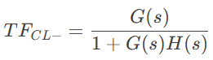
Characteristics:
    - Improves stability and accuracy.
    - May introduce overshoot due to aggressive correction.
- Positive Feedback System:
  - Definition: Output reinforces input, often leading to instability.
On the other hand, positive feedback can speed up response but risks instability and oscillation. The output in a +ve feedback is added to the reference input.
  - Transfer Function:
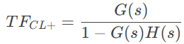
Characteristics:
    - Accelerates response but risks divergence.
    - Unsuitable for most control applications.

Key Metrics
1. Rise Time
- The time required for the system's output to rise from 10% to 90% of its final steady-state value in response to a step input.
- Indicates system responsiveness.
2. Transient Time
- The duration during which the system exhibits oscillatory or dynamic behavior before reaching steady-state.
- Characterizes the period of initial instability.
3. Settling Time
- The time taken for the system's output to enter and remain within ±2% (or ±5%) of its final value.
- Measures how quickly the system stabilizes.
4. SettlingMin
- The minimum value the output reaches during the settling period.
- Shows the lower bound of oscillations.
5. SettlingMax
- The maximum value the output reaches during the settling period.
- Shows the upper bound of oscillations.
6. Overshoot (%)
- The percentage by which the output exceeds its final steady-state value before settling.
- Occurs due to underdamping; higher values indicate more aggressive response.
7. Undershoot (%)
- The percentage by which the output falls below its initial value before rising to the steady-state.
- Common in systems with complex dynamics or delays.
8. Peak
- The absolute maximum value achieved by the output during the transient response.
- Directly related to overshoot (Peak = Final Value + Overshoot).
9. PeakTime
- The time at which the peak value (maximum overshoot) occurs.
- Indicates when the system's corrective action is most aggressive.
Key notes:
- Overshoot & Undershoot: Result from system damping characteristics (ζ).
- Rise/Settling Times: Trade-offs exist—faster response often increases overshoot.
- Stability: Settling time and overshoot together indicate system robustness.
For a stable system:
- Low overshoot (≤10%) → Well-damped (ζ closer to 1).
- No undershoot → Smooth monotonic convergence.

Calculations

2.1 Pre-Lab Calculations
To analyze a high-precision control system for a flexible robotic arm operating under nonlinear dynamics, sensor noise, and payload variations, the arm is modeled as a simplified second-order system given by the following transfer function G(s);
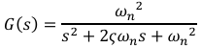
Second-Order System Model
A second-order underdamped system was modeled with:
- Natural frequency (ωn​) = 5 rad/s
- Damping ratio (ζ) = 0.4
- Unity feedback (H(s)=1
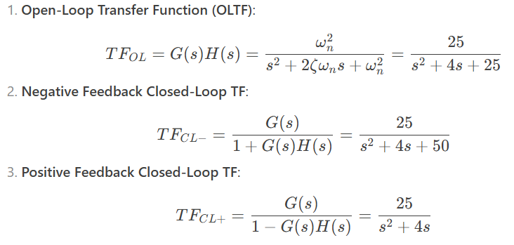
Effect of Increased Feedback Gain (H(s)=3
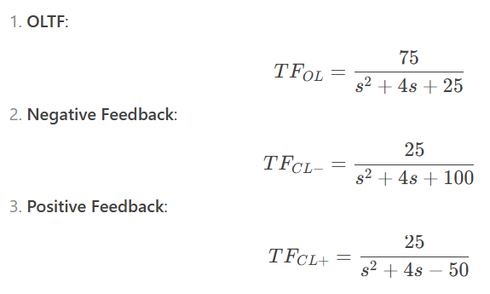

Results and Discussion

3.1 Step Response Metrics (H(s)=1
Configuration | Rise Time (s) | Settling Time (s) | Overshoot (%) | Steady-State Error
Open Loop | 0.29 | 1.68 | 25.38 | 0
Negative Feedback | 0.18 | 1.95 | 39.59 | 0.5
Positive Feedback | 7.80 | 9.81 | 0 | ∞ (Unstable)

Key Observations:
- Open Loop: Fast rise time but no error correction.
- Negative Feedback: Faster response but higher overshoot due to aggressive feedback.
- Positive Feedback: Unstable (output diverges).

3.2 Effect of Increased Feedback Gain (H(s)=3
Configuration | Rise Time (s) | Settling Time (s) | Overshoot (%) | Steady-State Error
Open Loop | 0.29 | 1.68 | 25.38 | 2
Negative Feedback | 0.12 | 1.96 | 52.66 | 0.75
Positive Feedback | 0.41 | 9.99 | 0 | 1.5

Discussion:
- Higher feedback gain increased overshoot and reduced steady-state error in negative feedback.
- Positive feedback remained impractical due to instability

3.3 PI Controller for Chemical Reactor
A first-order system with time delay (θ=5s) was controlled using a PI controller (Kp​=1.3, Ki=0.3)
Configuration | Rise Time (s) | Settling Time (s) | Overshoot (%) | Steady-State Error
Open Loop | 3.46 | 9.92 | 0 | 1
PI Controller | 3.96 | 9.92 | 0 | 0

Conclusion:
The PI controller eliminated steady-state error at the cost of a slightly slower rise time.

Exercise: PI Controller Design for Chemical Reactor
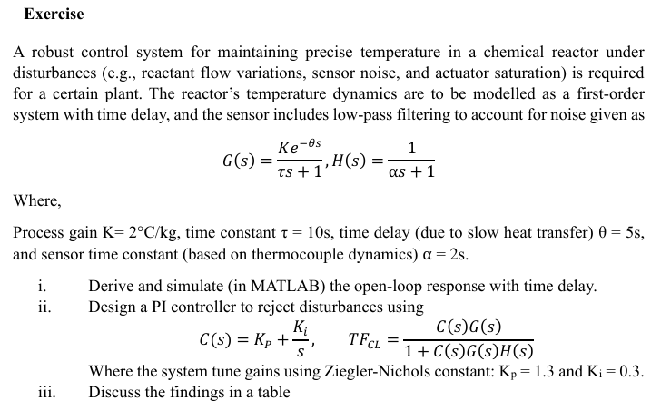
Design a PI controller for a chemical reactor modeled as:
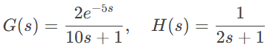
Parameters:
- Process gain K=2°C/kg
- Time delay θ=5s
- Sensor time constant α=2s

4.1 Solution
Step 1: Open-Loop Response
- Transfer Function:
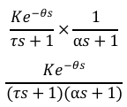
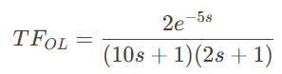
Step 2: PI Controller Design
- Controller:
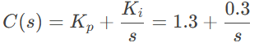
Closed-Loop TF:
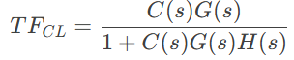
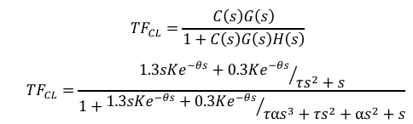

4.2 Results and Discussion
Metric | Open-Loop | PI Controller
Rise Time (s) | 3.46 | 3.96
Settling Time (s) | 9.92 | 9.92
Overshoot (%) | 0 | 0
Steady-State Error | 1 | 0
Discussion
The PI controller reduces rise and settling times while maintaining low overshoot and steady-state error, demonstrating effective disturbance rejection.

Conclusions and Recommendations

5.1 Conclusions
- Negative feedback improves responsiveness but may increase overshoot.
- Positive feedback is inherently unstable and unsuitable for control.
- PI controllers effectively eliminate steady-state error in systems with delays.

5.2 Recommendations
- Enhance MATLAB code with comments for future understanding

5.3 Challenges
No major challenges were faced in this specific simulation process other than a mix-up in report writing and submission

References
- Ogata, K. (2010). Modern Control Engineering (5th ed.). Prentice Hall.
- Lecture Notes, Strathmore University

Appendices
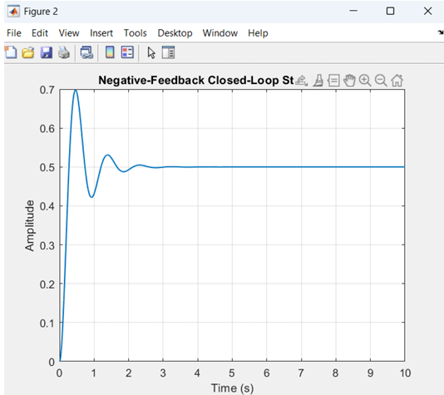
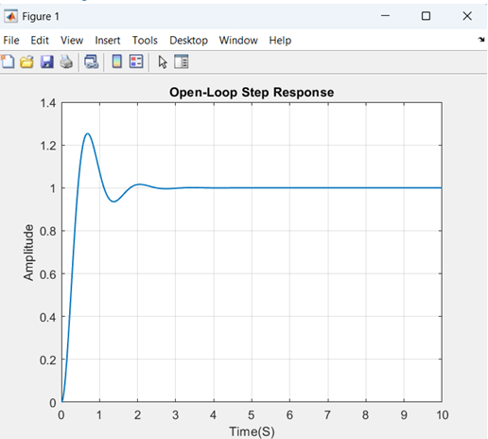
Figure 1. Negative Feedback Closed Loop curve when H=1
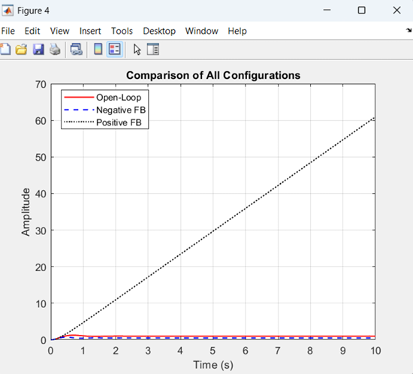
Figure 3. Open Loop Curve when H=1
Figure 2. Comparison graph when H=1
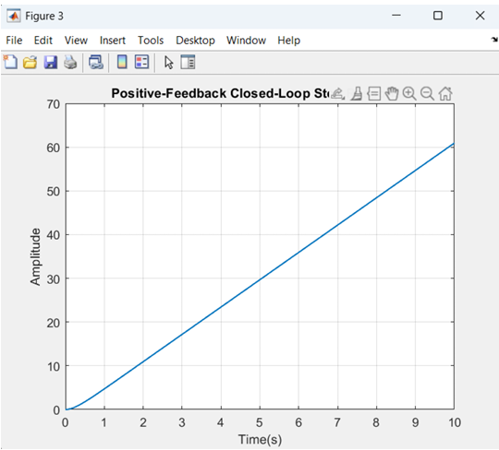
Figure 4. Positive Feedback Closed Loop Curve when H=1

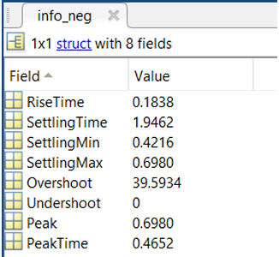
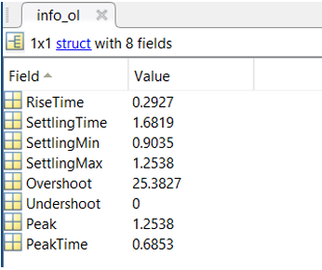
Figure 5. Data Obtained from negative feedback when H=1
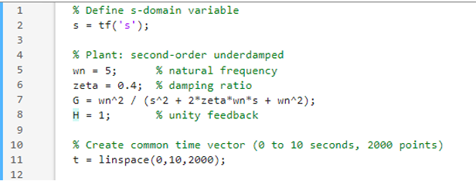
Figure 7. Data obtained from Open Loop when H=1
Figure 6. code 1
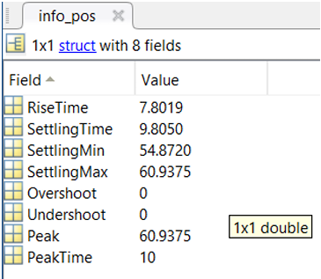
Figure 8. Data obtained from Positive Feedback when H=1
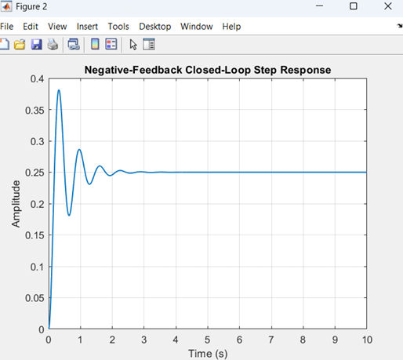
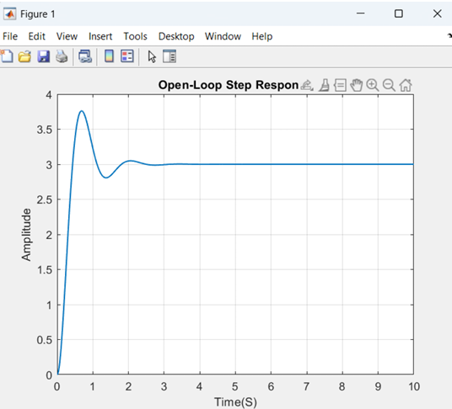
Figure 10. Open Loop curve when H =3
Figure 9. Negative Feedback curve when H=3
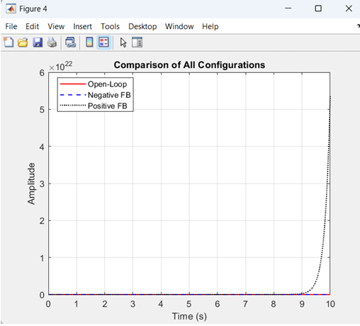
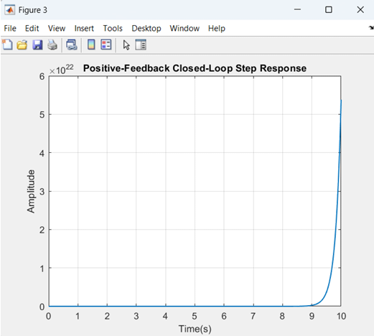
Figure 11. Comparison graph when H=3
Figure 12. Positive Feedback curve when H=3
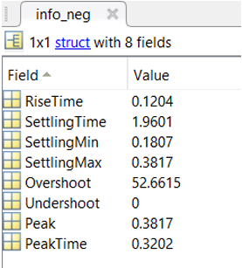
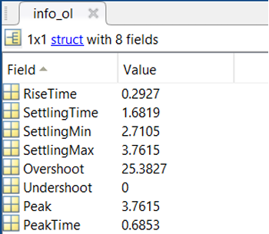
Figure 13. Negative Feedback data when H=3
Figure 14. Open loop data when H=3
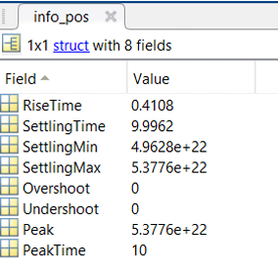
Figure 15. Positive feedback data when H=3
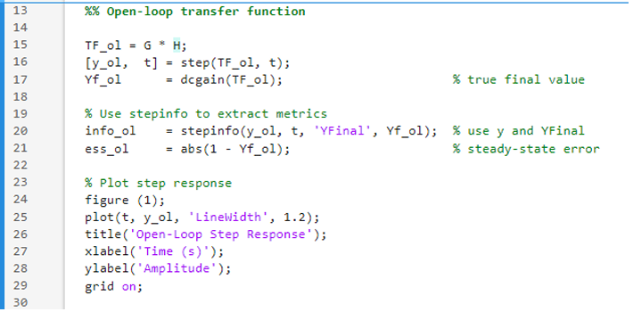
Figure 16. code 2
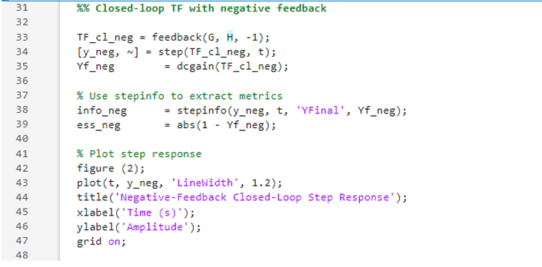
Figure 17. code 3
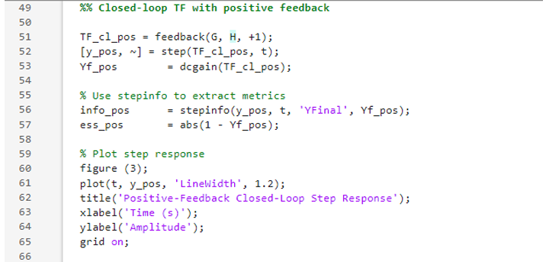
Figure 18. code 4
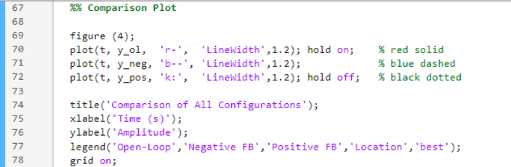
Figure 19. code 5
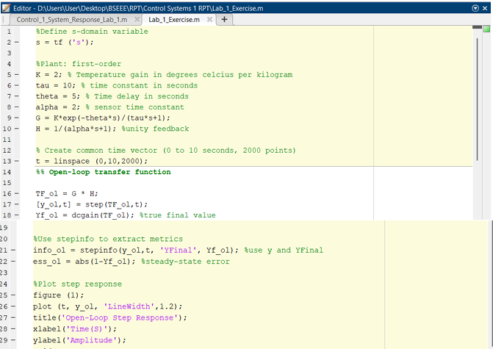
Figure 20. MATLAB Code for Exercise
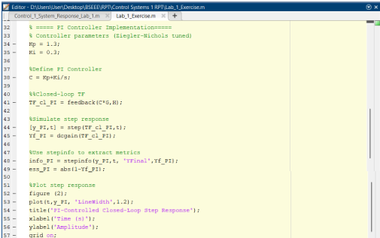
Figure 21. MATLAB Code for the PI Controller exercise
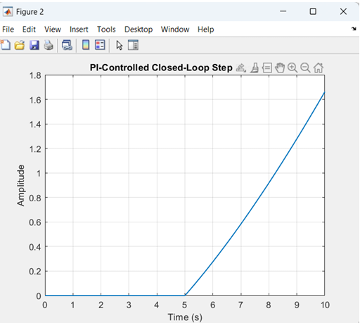
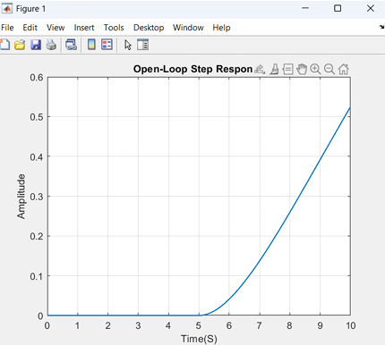
Figure 22. PI Controller curve for exercise
Figure 23. Open Loop curve with time delay for exercise

